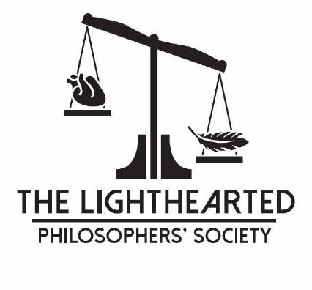
Call for Papers 2026 Lighthearted Philosophers’ Society
Dates: October 9-10, 2026
Location: Kurt Vonnegut Museum and Library
Accommodations: Sheraton Indianapolis City Centre
Please join us for the 20th anniversary meeting of the Lighthearted Philosophers’ Society (LPS) Meeting at the Kurt Vonnegut Museum and Library in Indianapolis, IN, October, 9-10.
The LPS is the oldest continuously running society dedicated to the philosophically inspired study of laughter and humor. The LPS encourages and welcomes submissions on topics related to humor and laughter and even humorous philosophical works. Individual submissions for a 1-hour presentation slot will be accepted in the form of extended abstracts (750-1000 words, including a brief 100-200 word overview). Panel proposals are also welcome. Please submit proposals here: (Link TBD)
For any inquiries or questions, please reach out to the current president of the LPS, Mike Cundall, here.
Further Information
- Individual submissions: Please submit a 750-1000 word extended abstract, including a brief 100-200 word overview of the project. Final papers should be prepared with limited time for presentation and discussion in mind.

- Panel proposal: Panel description should be 350-500 words and should specify what each panelist will contribute.

- Individual Short Performances: Submissions should include a 350-500 word rationale describing the theoretical contribution of the performance piece as well as a 350-500 word abstract describing the nature of the performance itself. Please include any audio-visual requests in the abstract.

Selected papers will be considered for the Joseph S. Ellin Memorial Essay Prize ($100)
Selected hecklers will be considered for the Richard C. Richards Almost Memorial Prize ($50)

Submission Deadlines TBA.

